


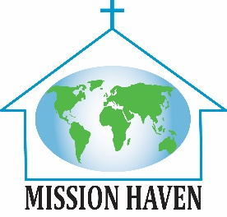

Mission Haven Update – December 2024
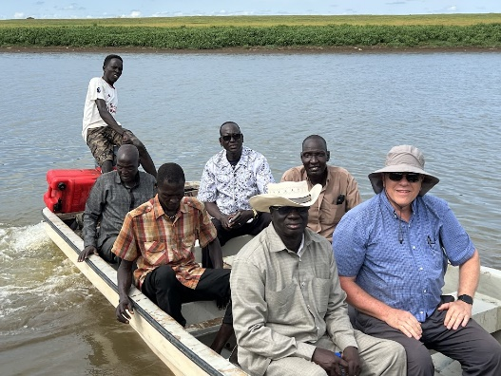
Celebrating Unity: An Advent Reflection

It was an absolutely beautiful day on the banks of the Sobat River (a tributary of the Nile), and that was only one of many miracles that day. Where gatherings are very weather-dependent, this clear, dry, only-mildly hot day, meant that thousands of people were able to gather and celebrate unity in the village of Nasir, South Sudan.
Church delegates from the capital flew in, and others walked in or came by boat. Many church choirs shared their gifts at the gathering. Speeches were given. It was a day of celebration and a day to commit to the completion of rebuilding a historic Presbyterian church in their village -- this is after decades of conflict and division, in society and in the church.
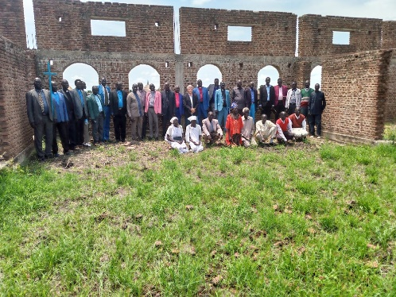
Another miracle was the presence and support of multiple factions within the church and civil society – coming together to support rebuilding this historic beacon of hope in the community. It was a rebirth of sorts, and a glorious celebration – ushering in a new era of peace and stability to the region.
It reminds me of the birth of our Prince of Peace, who came into the world to save us, redeem us, and bring us hope. And it is a tiny foretaste of the wondrous celebration we will have when He comes again, in power and glory. – Frank Dimmock
“See what love the Father has lavished on us that we may be called the children of God, and so we are.” – 1 John 3:1
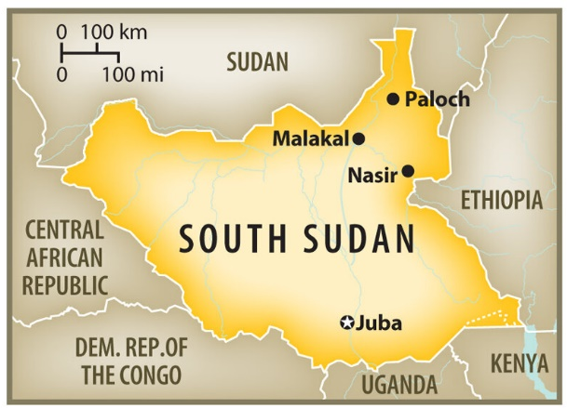
Prayer
Frank and his wife, Nancy, served as PCUSA mission co-workers in Malawi, Lesotho, and Zambia for 32 years after which Frank joined the Outreach Foundation as their Africa Mission Specialist. They, along with their 8 children (now grown), have been frequent residents of Mission Haven over the years. Frank retired this past September, and he and Nancy have purchased a home near Atlanta where they are new empty-nesters!
And we, together with our brothers and sisters in South Sudan, rejoice in Your mercy and love, Oh God, and are so thankful for the Peace made possible through Your Son, our Savior, Jesus Christ. Amen.

